Lockdown writing Task
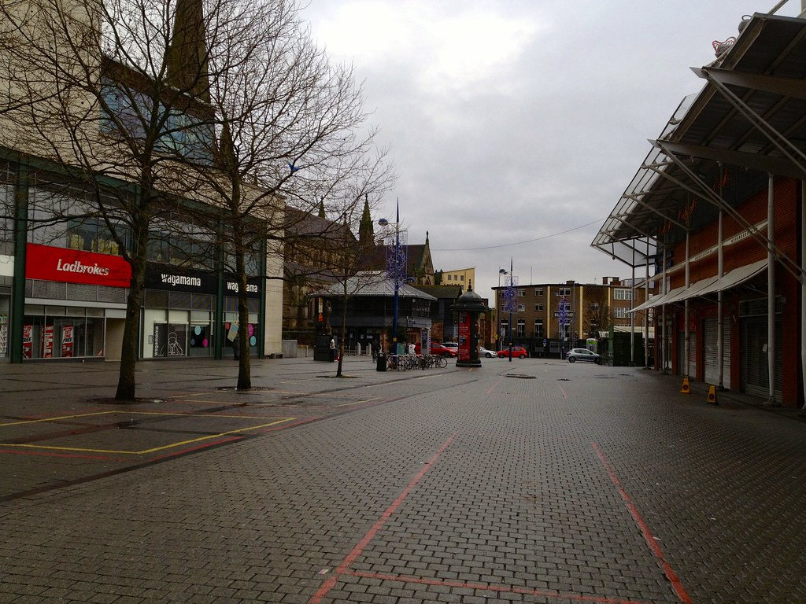

Lockdown is a new experience for everyone. For the safety of all and to protect the NHS, we have all been forced to stay indoors.
Your task is to write a story explaining your experiences during lockdown. This can be real or made up.

Remember to include:
- 5 senses (sight, smell, taste, touch, hearing)
- Descriptive language (Describe what you see around you, go into details)
- Emotive language (How does it make you/those around you feel)

Remember – if you get stuck, add a twist to your story.
