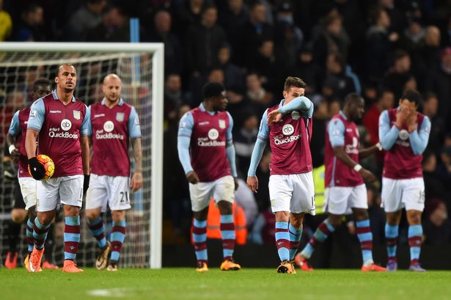
Is Aston Villa being relegated from the Premiership again?

Lockdown put a stop to Aston Villa’s run of form which could have seen then lifted out of the relegation zone. With the Premier League due to restart and having had months off, Aston Villa could well be relegated. Returning to form could take some time and time is against them. Your task is to write a letter of complaint to the Executive of the Premier League explaining why Aston Villa and the other bottom teams are disadvantaged.

Write to a persuasive letter to Richard Scudamore, executive of the Premier League. Explain your argument as to why no teams should be relegated or your own perspective on the predicament.

Remember
To balance your argument, giving both sides of the argument.
Use formal language appropriate to the letter.
Write in full paragraphs.

