Section B: Writing

You are advised to spend about 45 minutes on this section.
Write in full sentences.
You are reminded of the need to plan your answer.
You should leave enough time to check your work at the end.

Q5: A website has asked for examples of creative writing for its new page.

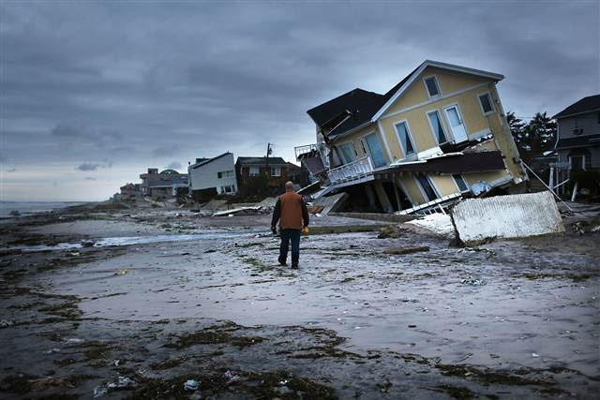
EITHER: Write a description as suggested by this picture:

OR: Write a short story that begins with the sentence: “It was a disaster. I didn’t know what to do.”

(24 marks for content and organisation
16 marks for technical accuracy)
[40 marks]

