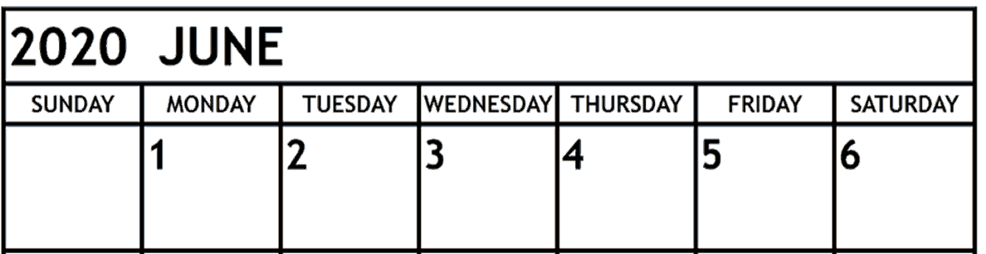
Over the next 5 days, write a diary entry for each day. Hopefully this will be your last two weeks away from school and in many years to come, you will be able to reflect on your lockdown, using your diary.

In each of your diary entries you should include:
- How you feel on that particular day
- Your thoughts on that day
- A description of life around you (i.e. did has your lawn grown another couple of centimetres in the past day, has another pile of plates and cups appeared next to your x-box)

You could start each day as;

Monday 1st June
Just another day in lockdown. I’ve lost count of how long I’ve not been able to go to school.

Or

Tuesday 2nd June
Day 72, this is worse than prison. My lawn looks like a jungle, I can’t even play football anymore. On the upside, my arms are lobster red from the hot sun, in a couple of day’s they’ll have turned to golden brown.

Use as much descriptive language as possible. Let the reader see the image which you’re trying to portray.

