A. Reading
Read the following article carefully and then answer the questions which follow it.
Planet Earth is 4,600 million years old. If we condense this inconceivable time span into an understandable concept, we can liken the Earth to a person of 46 years of age. Nothing is known about the first 7 years of this person's life, and whilst only scattered information exists about the middle 35 years, we know that only at the age of 42 did the earth begin to flower. Dinosaurs and the great reptiles did not appear until one year ago, when the planet was 45. Mammals arrived 8 month ago; in the middle of last week, human like apes evolved into ape like humans, and at the weekend the last ice age enveloped the Earth.
Modern Man has been been around for 4 hours. During the last hour Man discovered agriculture. The industrial revolution began one minute ago. During those sixty seconds of biological time, humans have made a rubbish tip of Paradise.
They have multiplied to plague proportions, caused the extinction of 500+ species of animals, ransacked the planet for fuels and now stand like a brutish infant , gloating over the meteroic rise to ascendency, on the brink of a war to end all wars and effectively destroying this oasis of life in the solar system..
From 'Against All Odds' - Greenpeace[1989]
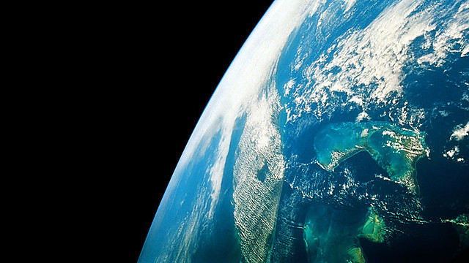
Photo Credit
1. Why does the writer liken Earth to a person of 46 years of age? Choose the most accurate answer.
a. to show that although the planet Earth is very young, man has had time to do a great deal of damage
b. to show in a more comprehensible way what a short time man has been on Earth
c. to show in a more comprehensible way how young the planet Earth is
d. to show that Earth is middle-aged
2. What is the writer suggesting when he describes the planet Earth as an "oasis of life in the solar system"?
3. Quote a phrase of two words which implies that man is very immature and behaves in an uncivilized way.
4. In your own words, say what the writer means by "humans have made a rubbish tip of Paradise".

