Section B: Writing

You are advised to spend about 45 minutes on this section.
Write in full sentences.
You are reminded of the need to plan your answer.
You should leave enough time to check your work at the end.

Q5: Your school magazine will be publishing a collection of creative writing written by students.

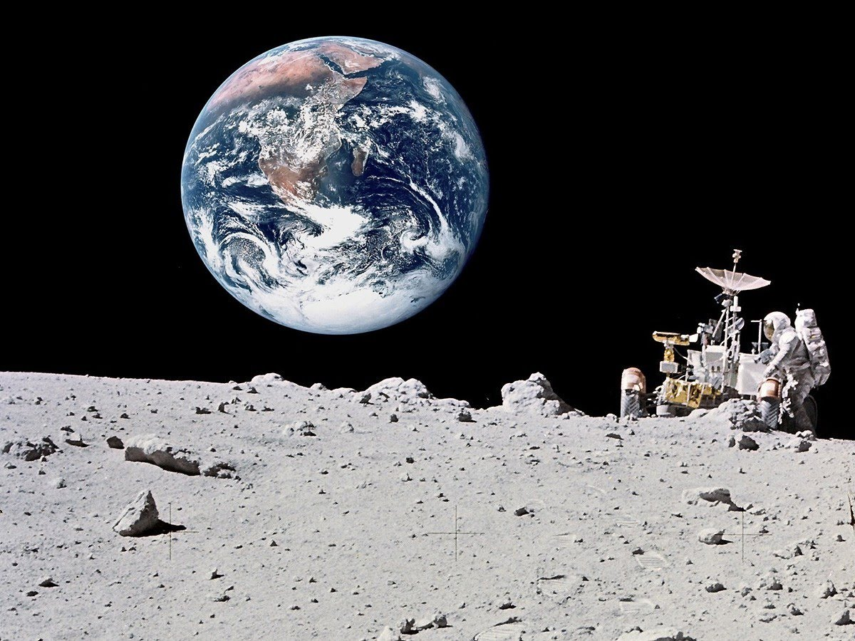
EITHER: Write a description as suggested by the picture:

OR: Write a story about something strange or unusual.

(24 marks for content and organisation
16 marks for technical accuracy)
[40 marks]

