01st July 2019

Summer News Letter 2019

Dear Parents/Carers,

As we approach the summer holidays, Oscott Academy celebrates its 5th birthday. Over the past 5 years we have had the privilege of working with almost 100 young people. To celebrate the achievements of each of the young people we have created a tree using the handprints of the young people.

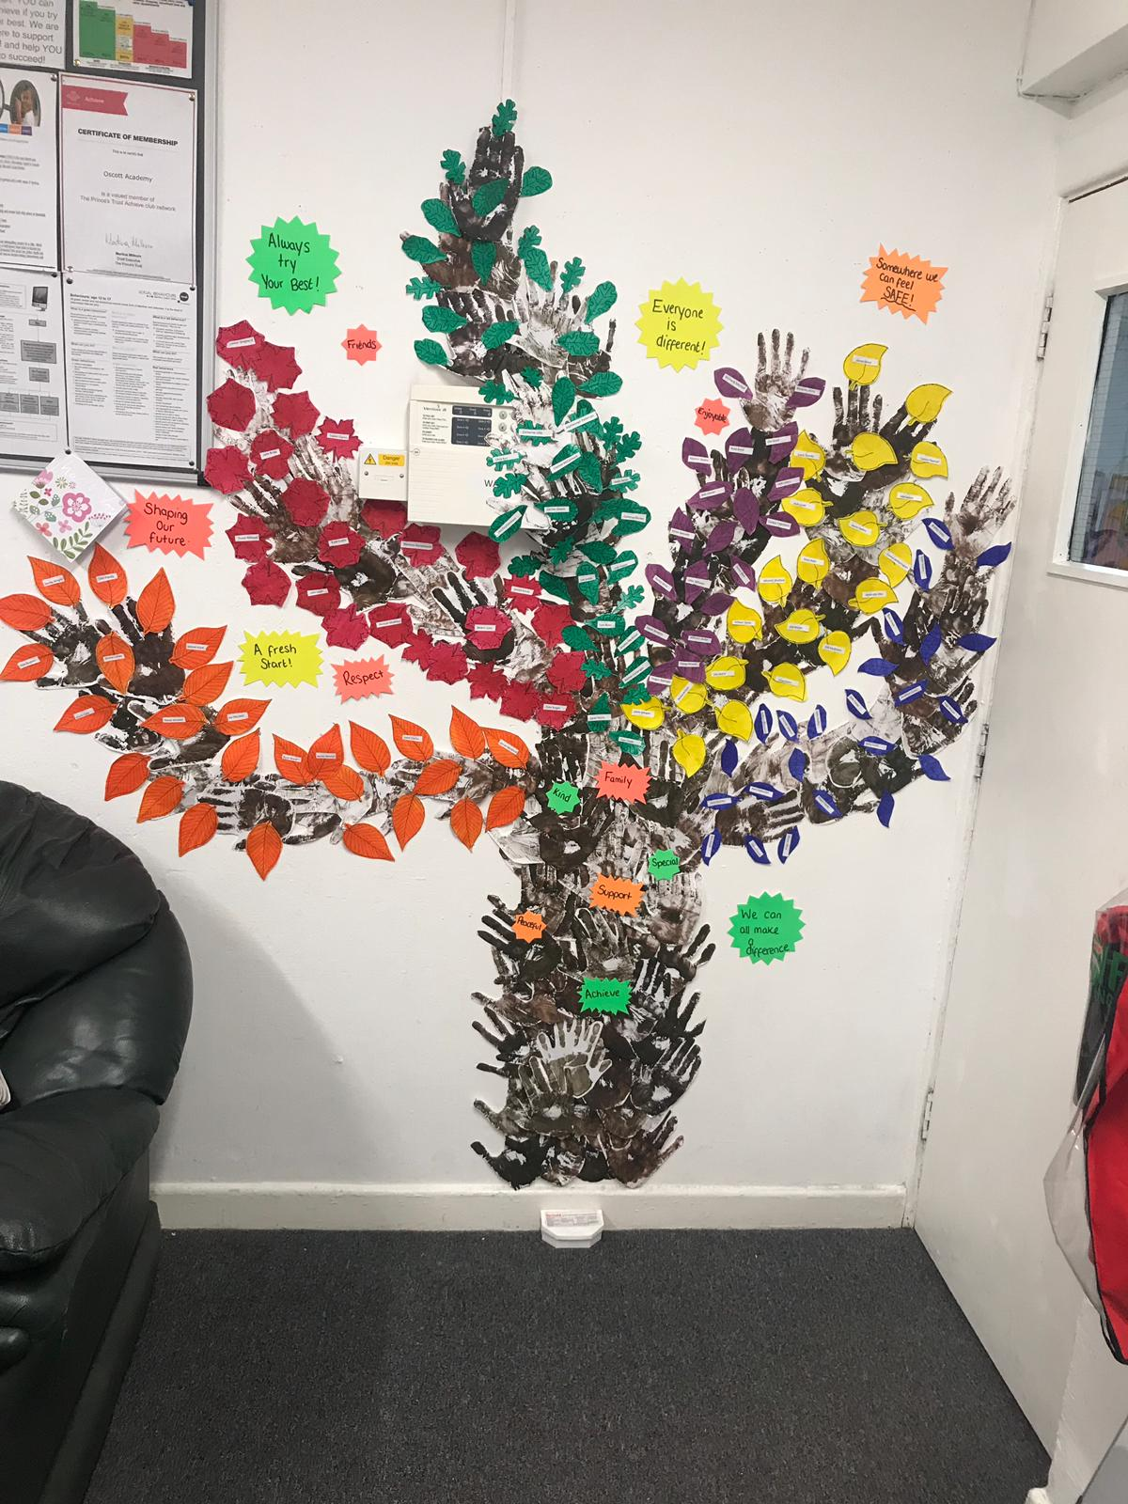
This summer, our Year 11 students have completed their GCSE Maths and English exams. We would like to invite the Year 11 students and parents to our summer graduation/results day on Thursday 22nd August 2019 at 10:30am.

This terms, Year 10 students focus has been on Functional Skills English and Maths in preparation for their exams in November. They have also be working towards GCSE work, personal development and AQA Unit Awards.

In September, our sports teacher, Mr Johnson, will be re-introducing the sports coaching qualification for the students. This gives students the opportunity to learn valuable leadership skills for their futures.

The 5 year celebration tree

Oscott Academy breaks up for the summer holidays on Friday 19th July 2019 and students return on Tuesday 3rd September 2019.

We hope you and your families have a lovely summer break and we look forward to helping your children to succeed next year.

