# Writing to describe

# GCSE Language: Paper 1

# Easter Holiday Revision

# Image result for show dont tell

# Name: _______________

Creative writing: Writing to describe

## Assessment Objectives:

**A05- Content and Organisation**

Communicate clearly, effectively and imaginatively, selecting and adapting tone, style and register for different forms, purposes and audiences.

Organise information and ideas, using structural and grammatical features to support coherence and cohesion of texts.

**A06- Technical Accuracy**

Use a range of vocabulary and sentence structures for clarity, purpose and effect, with accurate spelling and punctuation.

**How do you write to describe?**

1. You will be required to write a description based on a picture:

Or

1. Write the opening part of a story about a place that is severely affected by the weather.

**Grade 9: Success criteria:**

* Sophisticated vocabulary (verbs/adverbs/adjectives).
* Paragraph correctly (tiptop) your writing flows.
* Sentence variety (minor, simple, compound, complex, adverbial phrases).
* A detailed opening (setting) and climax.
* You write in the correct tense (past, present, future).
* Complex punctuation (: ; ! – ( ) … cliffhanger?
* Lists and triadic structure.
* Sensory language. You show, don’t tell.
* Extended similes, metaphors, personification and alliteration.
* Accurately punctuated direct speech/dialogue.
* Pathetic fallacy.

**Writing a story**

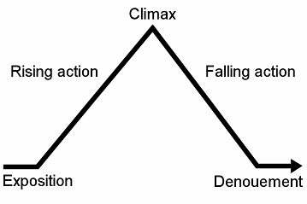

1. **Initial situation - the beginning.** It is the first incident that makes the story move.

2. **Conflict or Problem** - goal which the main character of the story has to achieve.

3. **Complication** - obstacles which the main character has to overcome.

4. **Climax** - highest point of interest of the story.

5. **Suspense - point of tension.** It arouses the interest of the readers.

6. **Denouement or Resolution** - what happens to the character after overcoming all obstacles and reaching his goal.

7**. Conclusion** - the end of the story.

**The opening to nineteen eighty four by George Orwell.**

It was a bright cold day in April, and the clocks were striking thirteen. Winston Smith, his chin nuzzled into his breast in an effort to escape the vile wind, slipped quickly through the glass doors of Victory Mansions, though not quickly enough to prevent a swirl of gritty dust from entering along with him.



Mark Scheme





**The Strange Case of Dr Jekyll and Mr Hyde** **by Robert Lewis Stevenson**

**Extract A- Gothic setting descriptions**

1. The street was small and what is called quiet, but it drove a thriving trade on the week days. The inhabitants were all doing well, it seemed, and all emulously hoping to do better still, and laying out the surplus of their gains in coquetry; so that the shop fronts stood along that thoroughfare with an air of invitation, like rows of smiling saleswomen. Even on Sunday, when it veiled its more florid charms and lay comparatively empty of passage, the street shone out in contrast to its dingy neighbourhood, like a fire in a forest; and with its freshly painted shutters, well-polished brasses, and general cleanliness and gaiety of note, instantly caught and pleased the eye of the passenger.

Two floors from one corner, on the left hand going east, the line was broken by the entry of a court; and just at that point, a certain sinister block of building thrust forward its gable on the street. It was two storeys high; showed no window, nothing but a door on the lower story and a blind forehead of discoloured wall on the upper; and bore in every feature, the marks of prolonged and sordid negligence. The door, which was equipped with neither bell nor knocker, was blistered and distained. Tramps slouched into the recess and struck matches on the panels; children kept shop upon the steps; no one had appeared to drive away these random visitors or to repair their ravages.

1. About three o’clock of a black winter morning, and my way lay through a part of town where there was literally nothing to be seen but lamps. Street after street, and all the folks asleep- street after street, all lighted up as if for a procession and all as empty as a church- till at last I got into that state of mind when a man listens and listens and begins to long for the sight of a policeman. All at once, I saw two figures[...]
2. It was a wild, cold, seasonable night of March, with a pale moon, lying on her back as though the wind had tilted her, and a flying wrack of the most diaphanous and lawny texture. The wind make talking difficult, and flecked the blood into the face, It seemed to have swept the streets unusually bare of passengers, besides; for Mr Utterson thought he had never seen that part of London so deserted. He could have wished it otherwise; never in his life had he been conscious of so sharp a wish to see and touch his fellow-creatures; for struggle as he might, there was borne in his mind a crushing anticipation of calamity. The square, when they got there, was all full of wind and dust, and the thin trees in the garden were lashing themselves along the railing.

**The Castle of Otranto by Horace Warpole (1964)**

This is widely considered to the first truly gothic novel. The nightmarish fear of being chased by a demonical character (Manfred) is powerfully captured here, and the setting and descriptive detail are definitely gothic.

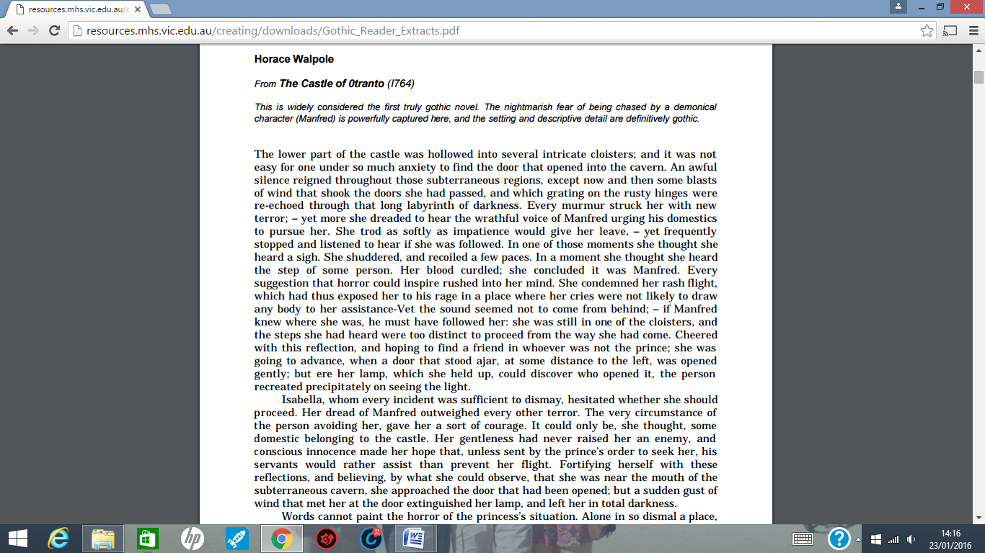

**Jane Austen from Northanger Abbey (1818)**

**Jane Austen, not really considered a gothic author, wrote Northanger Abbey as a parody of the gothic writers and reader she had encountered. In this excerpt, her heroine, Catherine, immersed as she is in the gothic, allows her imagination to run wild in the appropriate setting of Northanger Abbey at night.**

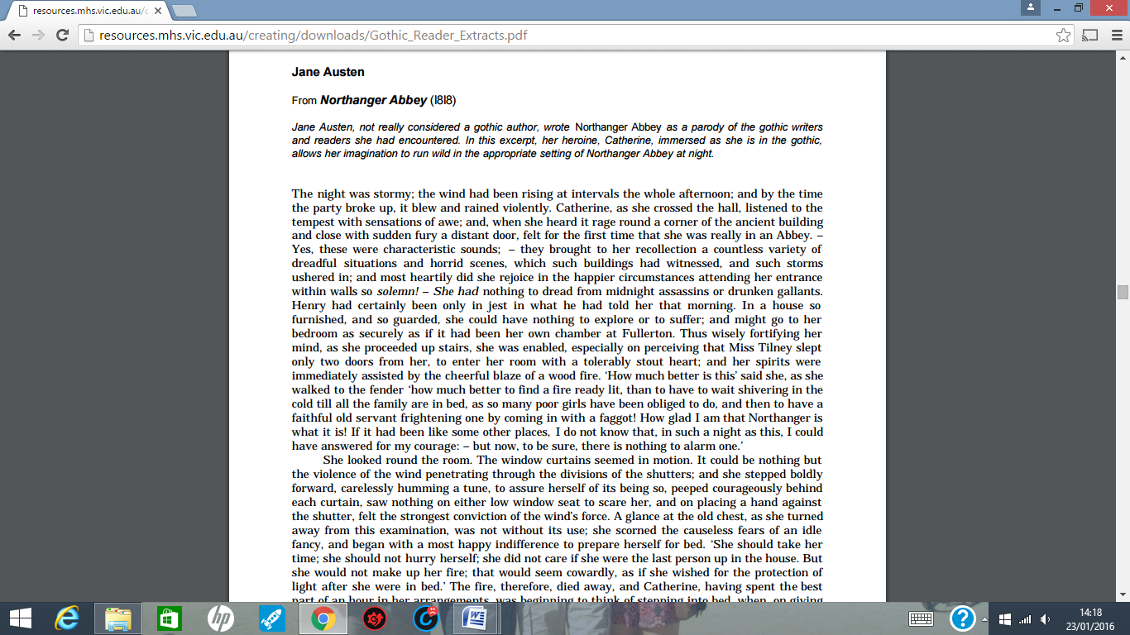

**The Woman in Black**

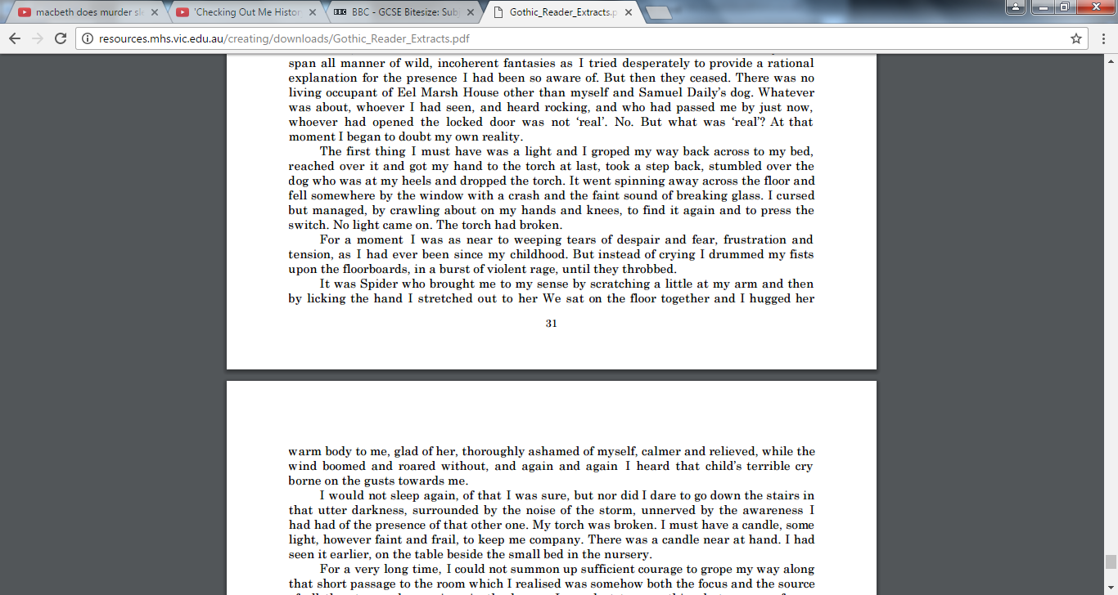



**Gothic Character Descriptions**

Mr Hyde snarled aloud into a savage laugh; and the next moment, with extraordinary quickness, he had unlocked the door and disappeared into the house.

The lawyer stood a while when Mr Hyde had left him, the picture of disquietude. Then he began slowly to mount the street, pausing every step or two and putting his hand to his brow like a man in mental perplexity. The problem he was thus debating as he walked was one of a class that is rarely solved. Mr Hyde was pale and dwarfish, he gave an impression of deformity without any nameable malformation, he had a displeasing smile, he had borne himself to the lawyer with a sort of murderous mixture of timidity and boldness, and he spoke with a husky, whispering and somewhat broken voice; all these were points against him, but not all of these together could explain he hitherto unknown disgust, loathing and fear with which Mr Utterson regarded him. ‘God Bless, the man seems hardly human! Something troglodytic, shall we say?” said the perplexed gentleman.

**Frankenstein by Mary Shelley**

**IT WAS** on a dreary night of November that I beheld the accomplishment of my toils. With an anxiety that almost amounted to agony, collected the instruments of life around me, that I might infuse a spark of being into the lifeless thing that lay at my feet. It was already one in the morning; the rain pattered dismally against the panes, and my candle was nearly burnt out, when, by the glimmer of the half-extinguished light, I saw the dull yellow eye of the creature open; it breathed hard, and a convulsive motion agitated its limbs.

How can I describe my emotions at this catastrophe, or how delineate the wretch whom with such infinite pains and care I had endeavoured to form? His limbs were in proportion, and I had selected his features as beautiful. Beautiful! -- Great God! His yellow skin scarcely covered the work of muscles and arteries beneath; his hair was of a lustrous black, and flowing; his teeth of a pearly whiteness; but these luxuriances only formed a more horrid contrast with his watery eyes, that seemed almost of the same colour as the dun white sockets in which they were set, his shrivelled complexion and straight black lips.

The different accidents of life are not so changeable as the feelings of human nature. I had worked hard for nearly two years, for the sole purpose of infusing life into an inanimate body. For this I had deprived myself of rest and health. I had desired it with an ardour that far exceeded moderation; but now that I had finished, the beauty of the dream vanished, and breathless horror and disgust filled my heart. Unable to endure the aspect of the being I had created, I rushed out of the room, continued a long time traversing my bed chamber, unable to compose my mind to sleep. At length lassitude succeeded to the tumult I had before endured; and I threw myself on the bed in my clothes, endeavouring to seek a few moments of forgetfulness. But it was in vain: I slept, indeed, but I was disturbed by the wildest dreams. [...] I started from my sleep with horror; a cold dew covered my forehead, my teeth chattered, and every limb became convulsed: when, by the dim and yellow light of the moon, as it forced its way through the window shutters, I beheld the wretch -- the miserable monster whom I had created. He held up the curtain of the bed and his eyes, if eyes they may be called, were fixed on me. His jaws opened, and he muttered some inarticulate sounds, while a grin wrinkled his cheeks. He might have spoken, but I did not hear; one hand was stretched out, seemingly to detain me, but I escaped, and rushed down stairs. I took refuge in the courtyard belonging to the house which I inhabited; where I remained during the rest of the night, walking up and down in the greatest agitation, listening attentively, catching and fearing each sound as if it were to announce the approach of the demoniacal corpse to which I had so miserably given life.

Oh! no mortal could support the horror of that countenance. A mummy again endued with animation could not be so hideous as that wretch. I had gazed on him while unfinished he was ugly then; but when those muscles and joints were rendered capable of motion, it became a thing such as even Dante could not have conceived.

I passed the night wretchedly. Sometimes my pulse beat so quickly and hardly that I felt the palpitation of every artery; at others, I nearly sank to the ground through languor and extreme weakness. Mingled with this horror, I felt the bitterness of disappointment; dreams that had been my food and pleasant rest for so long a space were now become a hell to me; and the change was so rapid, the overthrow so complete!

Morning, dismal and wet, at length dawned, and discovered to my sleepless and aching eyes the church of Ingolstadt, white steeple and clock, which indicated the sixth hour. The porter opened the gates of the court, which had that night been my asylum, and I issued into the streets, pacing them with quick steps, as if I sought to avoid the wretch whom I feared every turning of the street would present to my view. I did not dare return to the apartment which I inhabited, but felt impelled to hurry on, although drenched by the rain which poured from a black and comfortless sky.

**Great Expectations by Charles Dickens**

This is an extract from Dicken’s ‘Great Expectations’ where the protagonist Pip is forced to visit the reclusive Miss Havisham for the first time:

We went into the house by a side door-the great front entrance had two chains across it outside-and the first thing I noticed was, that the passages were all dark, and that she had left a candle burning there. She took it up, and we went through more passages and up a staircase, and still it was all dark, and only the candle lighted us.

*He then enters her room:*

I saw that everything within my view, which ought to be white, had been white long ago, and had lost its lustre, and was faded and yellow. I saw that the bride within the bridal dress had withered like the dress, and like the flowers, and had no brightness left but the brightness of her sunken eyes. I saw that the dress had been put upon the rounded figure of a young woman, and that the figure upon which it now hung loose, had shrunk to skin and bone. Once, I had been taken to see some ghastly waxwork at the Fair, representing I know not what impossible personage lying in state. Once, I had been taken to one of our old marsh churches to see a skeleton in the ashes of a rich dress that had been dug out of a vault under the church pavement. Now, waxwork and skeleton seemed to have dark eyes that moved and looked at me. I should have cried out, if I could.

It was when I stood before her, avoiding her eyes that I took note of the surrounding objects in detail, and saw that her watch had stopped at twenty minutes to nine, and that a clock in the room had stopped at twenty minutes to nine.

`Look at me,' said Miss Havisham. `You are not afraid of a woman who has never seen the sun since you were born?'

*Pip then visits her for a second time and she takes him to see another room:*

The most prominent object was a long table with a tablecloth spread on it, as if a feast had been in preparation when the house and the clocks all stopped together. An epergne or centre-piece of some kind was in the middle of this cloth; it was so heavily overhung with cobwebs that its form was quite undistinguishable; and, as I looked along the yellow expanse out of which I remember its seeming to grow, like a black fungus, I saw speckled-legged spiders with blotchy bodies running home to it, and running out from it, as if some circumstance of the greatest public importance had just transpired in the spider community.

**Paragraphing: We can use the acronym ‘TiPToP’ to help us remember when to change paragraphs**

Start a new paragraph when you change:

Time

Person

Topic

Place

Descriptive Writing

Either: Write a description based on this picture.

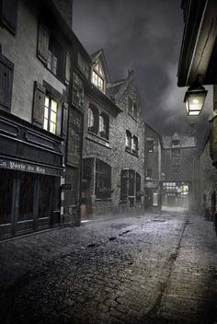

OR:

Describe an occasion when you felt intimidated arriving for the first time somewhere new. Focus on the thoughts and feelings you had at the time.

Word bank

|  |  |  |  |
| --- | --- | --- | --- |
|  |  |  |  |
|  |  |  |  |
|  |  |  |  |
|  |  |  |  |
|  |  |  |  |
|  |  |  |  |
|  |  |  |  |
|  |  |  |  |
|  |  |  |  |
|  |  |  |  |
|  |  |  |  |
|  |  |  |  |
|  |  |  |  |
|  |  |  |  |
|  |  |  |  |

|  |  |  |
| --- | --- | --- |
| STAGE Planning a short story | YOU SHOULD INCLUDE: | NOTES |
| EXPOSITION | **Write in first person, in present tense.**   * One word sentence. (Hook the reader) * Include a list of three adjectives. * Describe what you can see and feel and hear (5 examples of sensory language) Use detail. * Include a simile/metaphor * Include pathetic fallacy (create an atmosphere using the weather) |  |
| RISING ACTION | **Write in first person, in present tense.**   * Introduce your protagonist. * Include 3 **clues** about their personality/appearance/feelings. * *Use a metaphor to describe him/her* * Explain why your protagonist is in the setting she is. * *Use a sentence starting with the subordinate clause.* * Explain who the protagonist is with, or if he/she is alone. * *Use a three word sentence for effect.* * Use a simile. |  |
| CLIMAX | **Flashback to an important memory**  **Write in past tense- remember it is a flashback**   * Use a complex sentence to explain what has happened to that character. * Include an example of symbolism. * Begin a sentence with an adverb phrase * Continue to use sensory description * Create atmosphere through building tension * Sophisticated vivid imagery. |  |
| FALLING ACTION | **Still in the flashback**  **Still in past tense**   * MUST include a short piece of accurately punctuated direct speech/dialogue. * Use a comma (embedded clause) * BE ORIGINAL * Use effective and purposeful conversation |  |
| RESOLUTION | **Return to the present tense**   * Use interesting, sophisticated and varied vocabulary. * Resolve story or end on a cliffhanger? * Optional: Ellipsis (…) * No happy endings! * A twist? Unfinished ending? |  |