[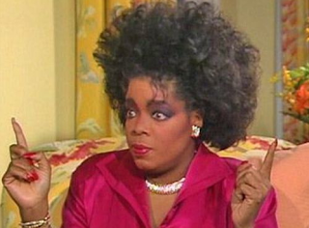](http://3.bp.blogspot.com/-m2dJJfaexdA/UcLVsVNOK3I/AAAAAAAAD1I/EJTV7hGv6hI/s1600/What+is+Hyperbole?.png)[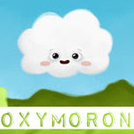](http://3.bp.blogspot.com/-MpGQS7-zp8I/UcyDG1JuERI/AAAAAAAAEEg/URbRFFLaZrU/s152/Oxymoron+small.jpg)[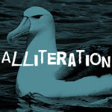](http://3.bp.blogspot.com/-amR9EifB2F0/UcyJakYhvmI/AAAAAAAAEFs/za0E25bD0SE/s150/alliteration+small.jpg)

An oxymoron is two words which are opposites, put together e.g. ‘organised mess’, ‘alone in a crowd’, ‘accidentally on purpose’, ‘deafening silence’.

Hyperbole is deliberate, sometimes outrageous exaggeration for effect e.g. 'I'm starving!'* (when you're merely hungry)

An alliteration is a sequence of words that start with the same letter (or sound) e.g. **A**rthur the **A**mazing **A**lbatross

[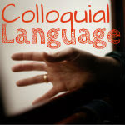](http://englishtutorhome2.blogspot.co.uk/2013/04/what-is-colloquial-language.html)

This is a phrase or word that doesn't obviously translate. It can also be described as 'informal language' e.g. 'give me a hand' = 'assist me'. Colloquial language is often a [metaphor](http://englishtutorhome2.blogspot.co.uk/2013/06/what-is-metaphor-definition-how-is-it.html).

[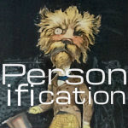](http://englishtutorhome2.blogspot.co.uk/2013/04/what-is-personification-definition-and.html)[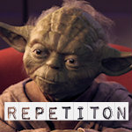](http://englishtutorhome2.blogspot.co.uk/2013/06/how-to-write-about-repetition-for.html)

This is where things (and animals) are given human qualities or emotions. Examples: sunlight danced on the water; wind whistled through the trees; night crept over the earth; creatures screamed in the night

Repetition is used to create emphasis, show connections, how ideas transform, develop, build. It can be done at the level of sounds (letters), words or ideas - in a range of patterns.

[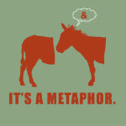](http://englishtutorhome2.blogspot.co.uk/2013/06/what-is-metaphor-definition-how-is-it.html)

Metaphors and similes are a type of word-magic. They conjure up two ideas - the thing you’re literally describing, and something else as well. Similes use the word ‘like’ or ‘as’ e.g. My brother eats **like** a pig.

[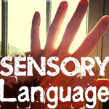](http://englishtutorhome2.blogspot.co.uk/2013/04/what-is-sensory-language.html)

It is a description that appeals to the five senses in a noticeable way. The air was **warm, thick, heavy, sluggish.**

[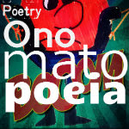](http://englishtutorhome2.blogspot.co.uk/2013/03/what-is-onomatopoeia.html)

It is a word that sounds like what it describes *Crash, bang, thump, boom, bang, hiss, plop, whistle, rustle*, are the clearest examples.