Summer News Letter 2021
Dear Parents/Carers
As we approach the summer holidays, this has been a very strange year for our students. We would like to congratulate all of our students who have tried their hardest throughout this uncertain time.
This summer our Year 11 students have completed their GCSE Maths and English mock exams and we would like to invite the Year 11 students and their parents/carers to our summer graduation/result day on Thursday 12th August 2021 at 10:30am.
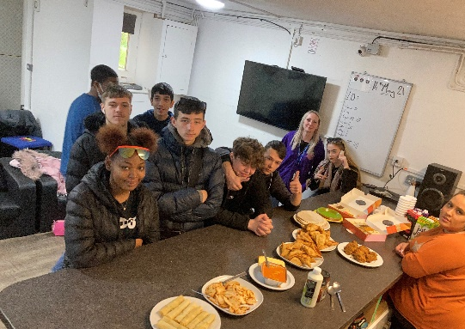
This term we have been celebrating more religious festivals where our students have been trying food from different cultures. We have also been celebrating Eid this term.
This term, Year 10 students focus has been on Functional Skill Maths and English in preparation for their exams in November. They have also be working towards GCSE work, AQA unit awards and personal development.
Oscott Academy breaks up for the summer holidays on Monday 19th July 2021 and students will return on Monday 6th September 2021.
We would like to thank you for you cooperation though out this uncertain time during coronavirus. We will continue to test students twice a week at the start of the school day on Monday’s and Thursday’s can you ensure your child is in school for 8:30 on those days. We will continue to update you with any changes once these have been given to use by the government.
We hope you and your families have a lovely summer break and we look forward to helping your children to succeed next year.

