Expand 3(2x – 7)  Expand and simplify (x + 2)(x + 3) | There are 59 people living in a country. Ten years later there are  5 times as many people living in the country. How many people now live in the country? | How many lines of symmetry does a rhombus have?  What order of rotational symmetry does have a rhombus have? | Calc - Gianna is planning a theatre trip. The costs are given below:  Coach (53 seats) £410 per coach  Food £13 per person  Theatre ticket £34 per person  A ticket for the theatre trip costs £58. Eighty-seven people buy a ticket. Is this enough money?
Tom has to put 1000 bottles into crates. One crate will take 24 bottles.  How many crates will Tom need? | Calc - Calculate 37% of £720 | Hannah says that there are 3 numbers between 110 and 210 that have 25 as a factor. Is she correct? Explain your answer. | How many vertices has a square based pyramid
Party hats are sold in packets of 10. Balloons are sold in bags of 15. Party poppers are sold in packs of 12.  Brianna wants to buy the same number of party hats, balloons and party poppers. What is the smallest number of each item she could buy? | Find angle d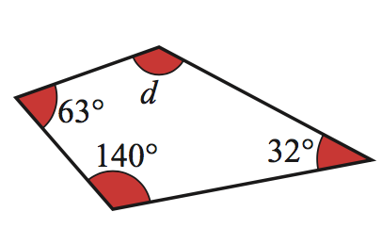 | Lola has £12 in her bank account. The bank will allow her to go up to £50 overdrawn. She wants to buy a £22 scarf for her dog and a £39 jumper for herself. Can she use her bankcard to buy the scarf  and jumper? | Calculate 5/9 of 81

