12th April 2019

Spring News Letter

Dear Parents/Carers,

This term we have seen the Year 11 students complete their first round of Functional Skill Maths and English exams at level 1 and level 2. We are pleased to announce that the students provisional marks are back and that 85% of exams were passed. A huge well done to the students. Those who did not reach the pass mark will have the opportunity to re-sit the exams in May.

This term students have worked towards both Functional Skills and GCSE’s in English and Maths and Science, alongside Princes Trust Level 2 Award, AQA Unit Awards and much more.

As we approach the summer, can I please remind parents that students attendance is vitally important if they are to maximise their chances of success.

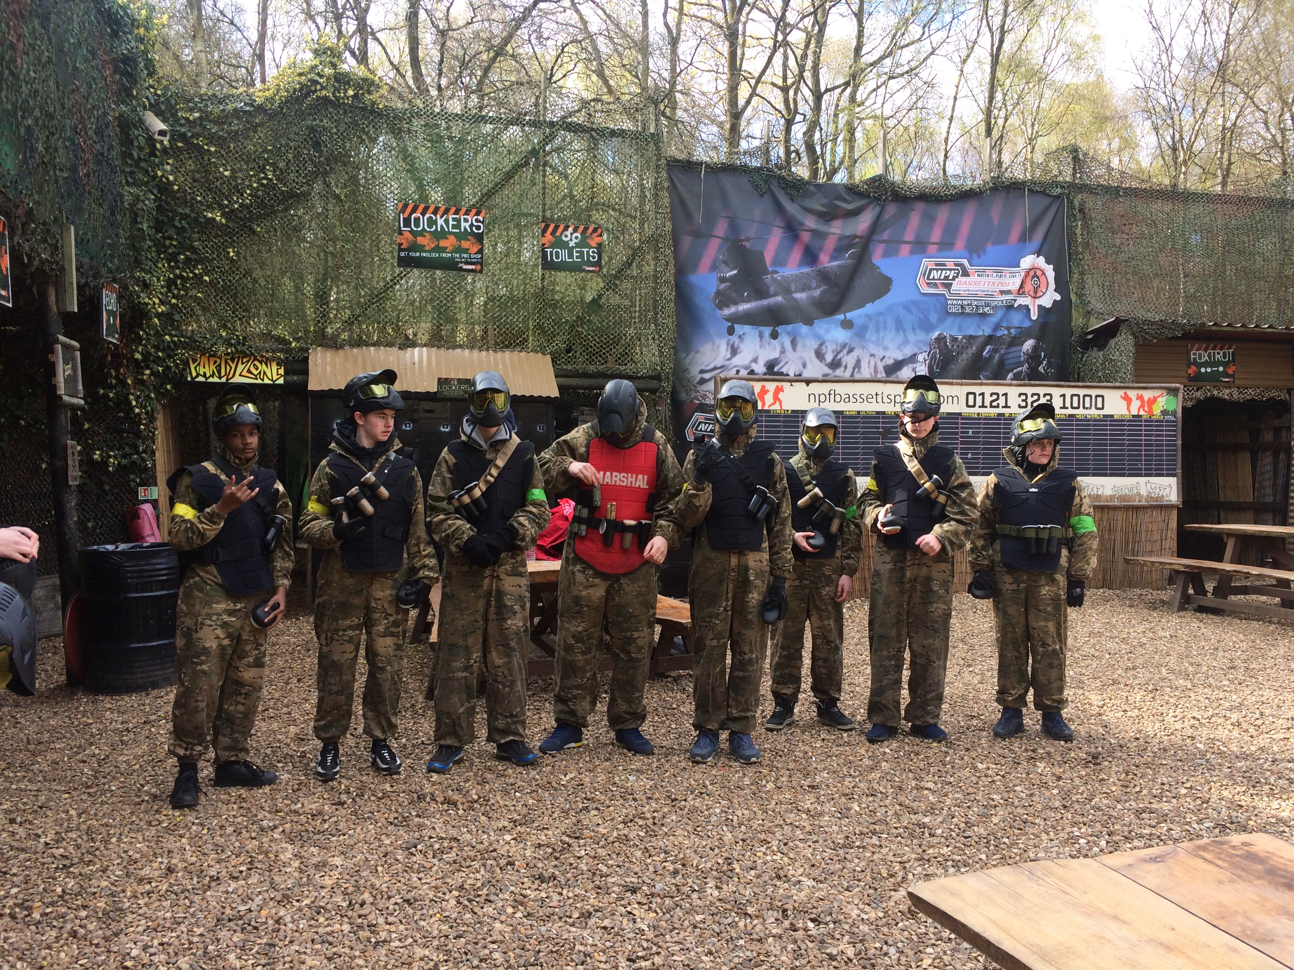
Paintball Rewards Trip 2019

The summer exam timetable is now published on our website and we would also like to invite you to our annual graduation/results day on Thursday 22nd August 2019 at 10:30am.

We thank you for your continued support.

