18th December 2018

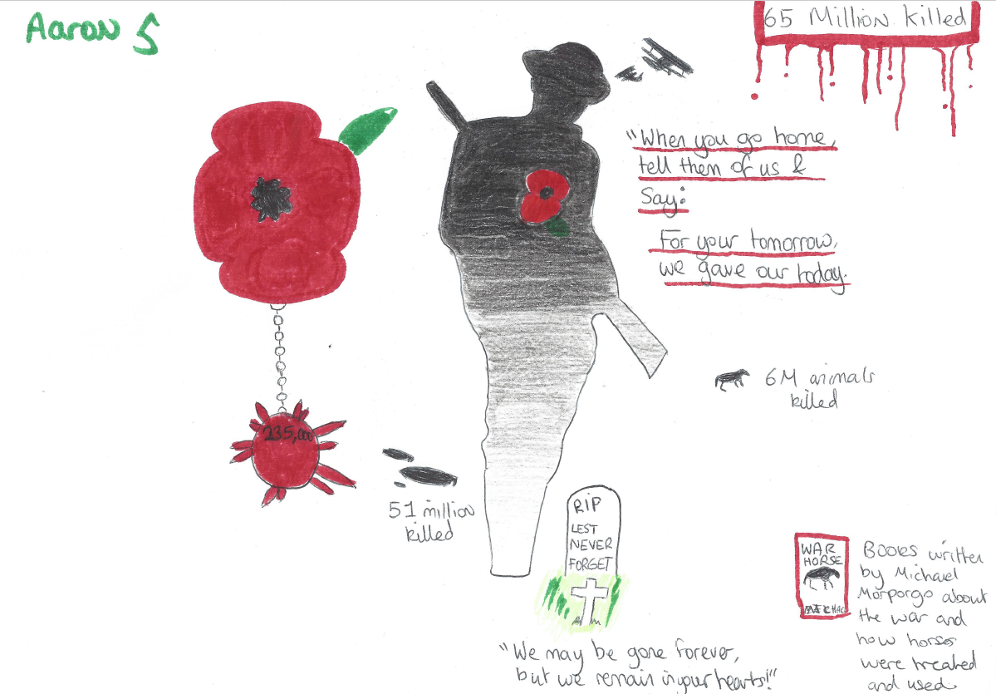
(100 year centenary celebration artwork by Aaron Stead)

Dear Parents/Carers,

The students have worked hard this term and are working towards their impending Functional Skill English and Maths exams alongside GCSE’s. Each of our Year 11 students have successfully passed the Speaking and Listening element and we are confident that they will do well in their upcoming exams.

Please see below our upcoming exam dates for the first round of exams:

Monday 25th February 2018 Functional Skills English (AM and PM)
Tuesday 26th May 2018 Functional Skills Maths Paper (AM)

We break up for the Christmas holidays on Friday 21st December following our “Alternative Christmas dinner”. Students return to school on Tuesday 8th January.

I would like to take this opportunity to remind parents/carers the importance of high school attendance and timekeeping as this has a massive impact of achievement.

We wish you and your families a Merry Christmas and a Happy New Year.

Kind regards

Stewart Dance
Head Teacher

