**Letter template**

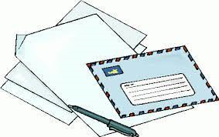

**Recipient’s information**

**Your information**

**Final Paragraph/ Conclusion**

**Third Paragraph**

**Seccond Paragraph**

**First Paragraph**

Dear (insert name)