Expand 3(2x – 7) – 2(3x + 5)  Expand and simplify (x + 2)(x + 3) | Find the area of this triangle, giving your answer in standard form.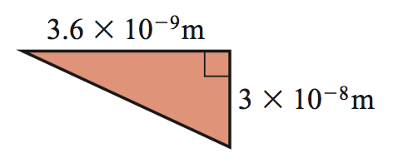 | Solve: 3x – 1 = 5x + 7  Find the actual perimeter;  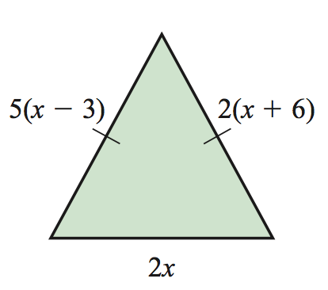 | Calc - Gianna is planning a theatre trip. The costs are given below:  Coach (53 seats) £410 per coach  Food £13 per person  Theatre ticket £34 per person  A ticket for the theatre trip costs £58. Eighty-seven people buy a ticket. Is this enough money?
Tom has to put 1000 bottles into crates. One crate will take 24 bottles.  How many crates will Tom need? | Calc - A clock is bought for £60 and sold for £69. What is the percentage profit?  Aaliyah earns £30 797 in 2015 which is 3% more than her salary in 2014. Owen earned £28 500 in 2013. The following year he received a 4% pay rise. Who earns more money in 2014 and by how much? | Hannah says that there are 3 numbers between 110 and 210 that have 25 as a factor. Is she correct? Explain your answer. | Find the perimeter, simplify your answer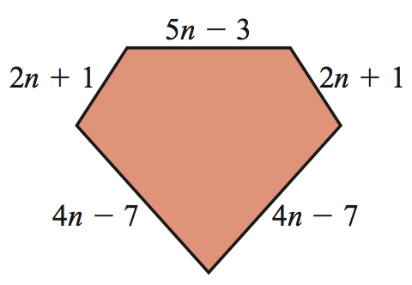
Party hats are sold in packets of 10. Balloons are sold in bags of 15. Party poppers are sold in packs of 12.  Brianna wants to buy the same number of party hats, balloons and party poppers. What is the smallest number of each item she could buy? | Find angle q, r and s.  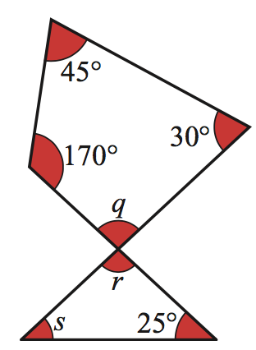 | Lola has £12 in her bank account. The bank will allow her to go up to £50 overdrawn. She wants to buy a £22 scarf for her dog and a £39 jumper for herself. Can she use her bankcard to buy the scarf  and jumper? | Calculate 5/9 of 81  Calc - Abdullah invests some money in a bank at 8% p.a. compound interest. After how many years will his money have doubled?

